**Raspberry Pi Screen Instructions**

**Accessories**

1. **Screen**
2. **HDMI Cable**
3. **Micro USB Power Cable**

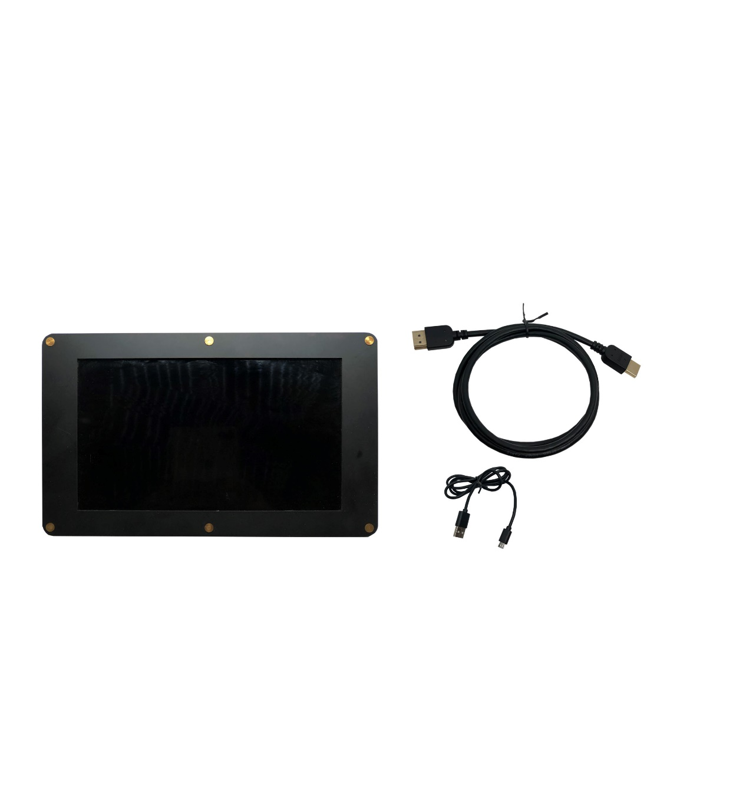

**Modify the Raspberry Pi launch configuration：**

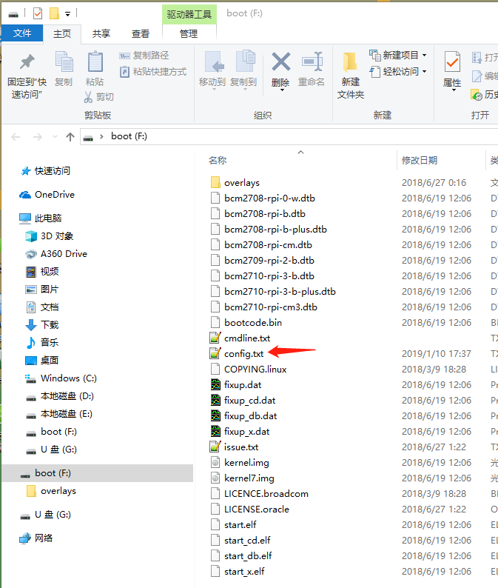Open the Raspberry Pi startup TF card on the computer and find the config.txt startup configuration file**.**

Add the corresponding initialization parameter configuration code of the screen at the bottom of the configuration file.**：**

**5 inch screen config：**

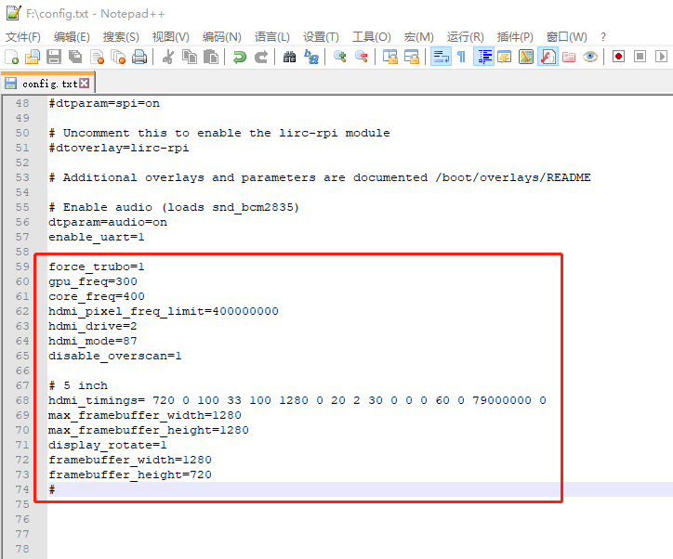

**force_trubo=1**

**gpu_freq=300**

**core_freq=400**

**hdmi_pixel_freq_limit=400000000**

**hdmi_drive=2**

**hdmi_mode=87**

**disable_overscan=1**

**# 5 inch**

**hdmi_timings= 720 0 100 33 100 1280 0 20 2 30 0 0 0 60 0 79000000 0**

**max_framebuffer_width=1280**

**max_framebuffer_height=1280**

**display_rotate=1**

**framebuffer_width=1280**

**framebuffer_height=720**

**#**

**7 inch screen config：**

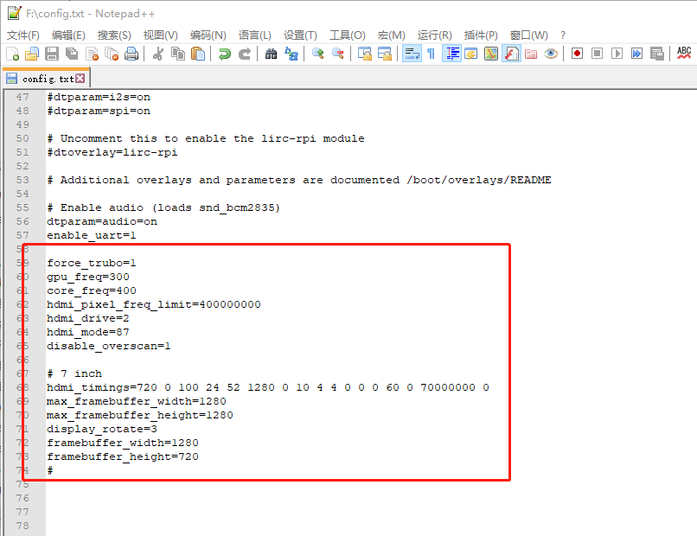

**force_trubo=1**

**gpu_freq=300**

**core_freq=400**

**hdmi_pixel_freq_limit=400000000**

**hdmi_drive=2**

**hdmi_mode=87**

**disable_overscan=1**

**# 7 inch**

**hdmi_timings=720 0 100 24 52 1280 0 10 4 4 0 0 0 60 0 70000000 0**

**max_framebuffer_width=1280**

**max_framebuffer_height=1280**

**display_rotate=3**

**framebuffer_width=1280**

**framebuffer_height=720**

**#**

**10.1 inch screen config：**

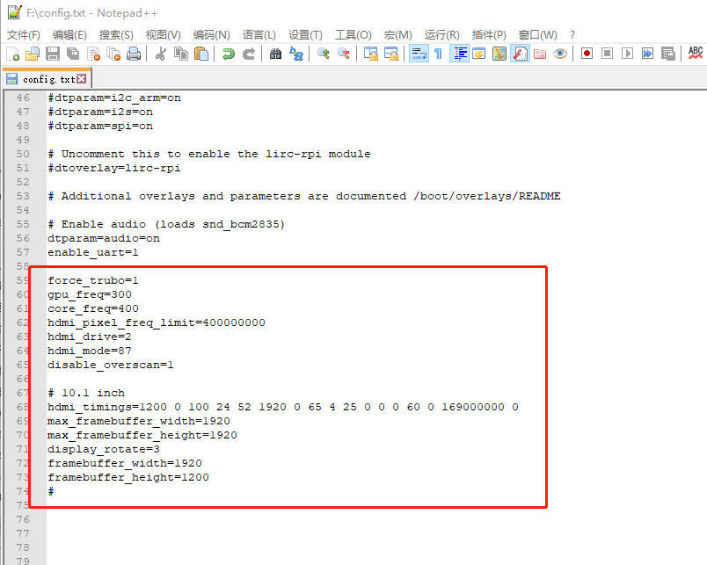

**force_trubo=1**

**gpu_freq=300**

**core_freq=400**

**hdmi_pixel_freq_limit=400000000**

**hdmi_drive=2**

**hdmi_mode=87**

**disable_overscan=1**

**# 10.1 inch**

**hdmi_timings=1200 0 100 24 52 1920 0 65 4 25 0 0 0 60 0 169000000 0**

**max_framebuffer_width=1920**

**max_framebuffer_height=1920**

**display_rotate=3**

**framebuffer_width=1920**

**framebuffer_height=1200**

**#**

**Power on, connect to raspberry pi or computer**

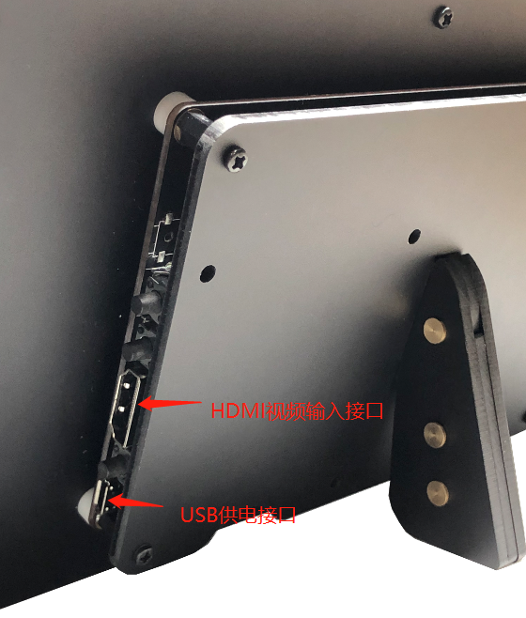

**Step 1: Connect the Micro USB power supply**

**Description: 5 inch, 7 inch can be powered by ordinary USB interface, 10.1 inch because the current required is larger than the maximum supply current of USB2.0 (500mA), it is recommended to use USB3.0 interface or use mobile phone charger and other supply current Standalone USB power supply that meets or exceeds 1A.**

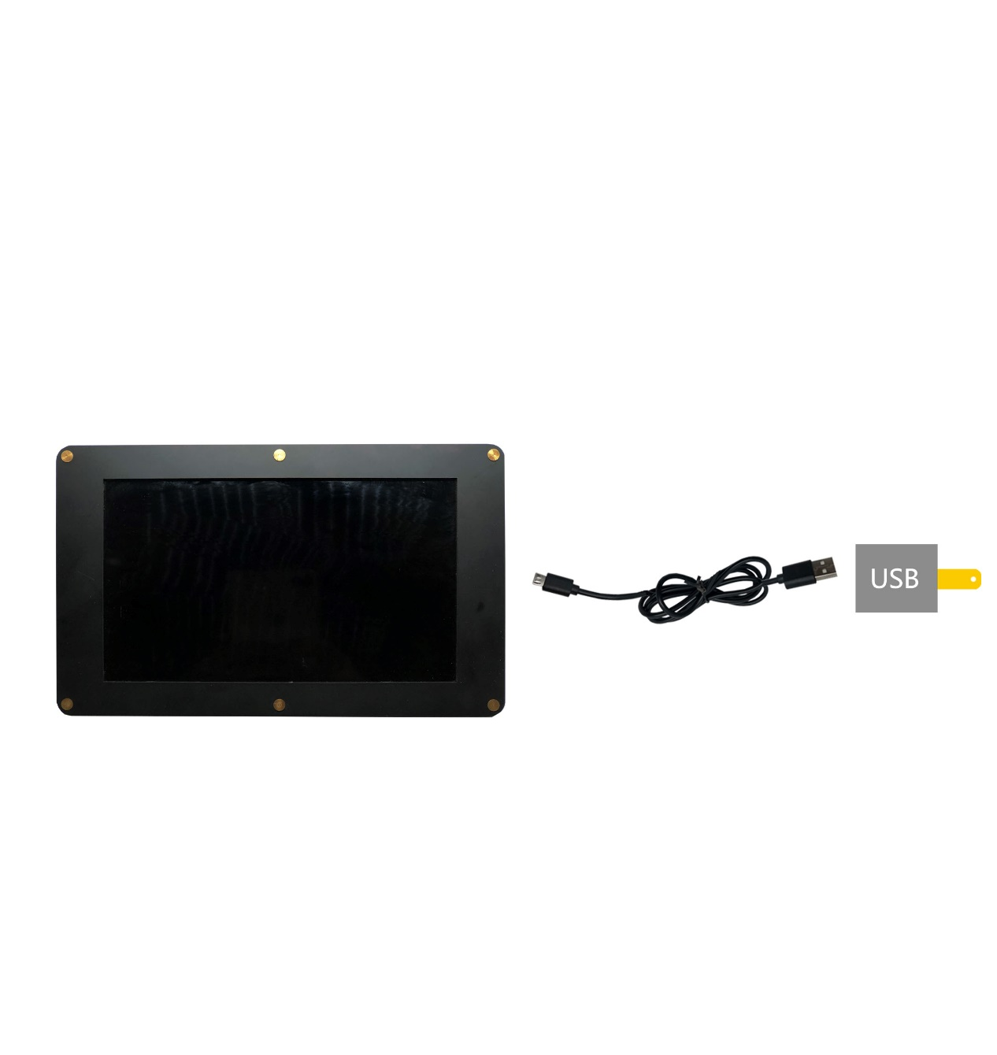

**Step 2: Connect an HDMI video source (Raspberry Pi or PC, notebook, or other standard HDMI video source)**

